**We analyzed Seattle Airbnb data – Here’s what we learned**

**Introduction**

Airbnb is an online marketplace which lets people rent out their properties or spare rooms to guests. Since the company launched in 2009, it’s grown from helping 21,000 guests a year find a place to stay to helping six million a year go on holiday, and currently lists a staggering 800,000 properties in 34,000 cities across 90 different countries. 

**Inspiration**  
In this project we will analyze the homestay dataset from Seattle, WA (USA). We got the data from [Kaggle](https://www.kaggle.com/airbnb/seattle/data). There were primarily three datasets provided to us, viz: 1. Calendar - This gives us the information whether the property is available for a certain period or not; if it is available the cost involved in blocking the property is also mentioned

2. Listings - This dataset tells us about the property. It will also provide information about owner's credibility, property quality, occupancy, etc.

3. Reviews - This dataset provides reviews that users gave over time.

Seattle is very old city and among the largest on the west coast of USA. I was curious to know what’s the impact of a platform network company such as Airbnb in Seattle. Presenting my thoughts as few questions would definitely help. Hence, here I will try to solve few questions which I am listing them down below:

1. Which is the most popular neighborhood in Seattle? And similarly which is the least popular area in Seattle? What can we tell by looking at their monthly pricing trends?
2. How does price fluctuate over time? Is there any seasonal effect over pricing?
3. What are the main amenities? There will be many in the catalog but we will try to find the main profiles
4. What are the different features that decide the pricing?
5. Can we classify the properties? It would be nice to see what features bring the properties together and what separates them

**Part 1: Most popular neighborhood of Seattle**

The question I really wanted to answer was which neighborhood is highly rated. Higher the scores it generates from its customers, higher the popularity would be. Each neighborhood was rated on the basis of cleanliness, communication, location, value, etc. on the scale of 1-10 (10 being the highest). I averaged them out and then plotted them on descending order.

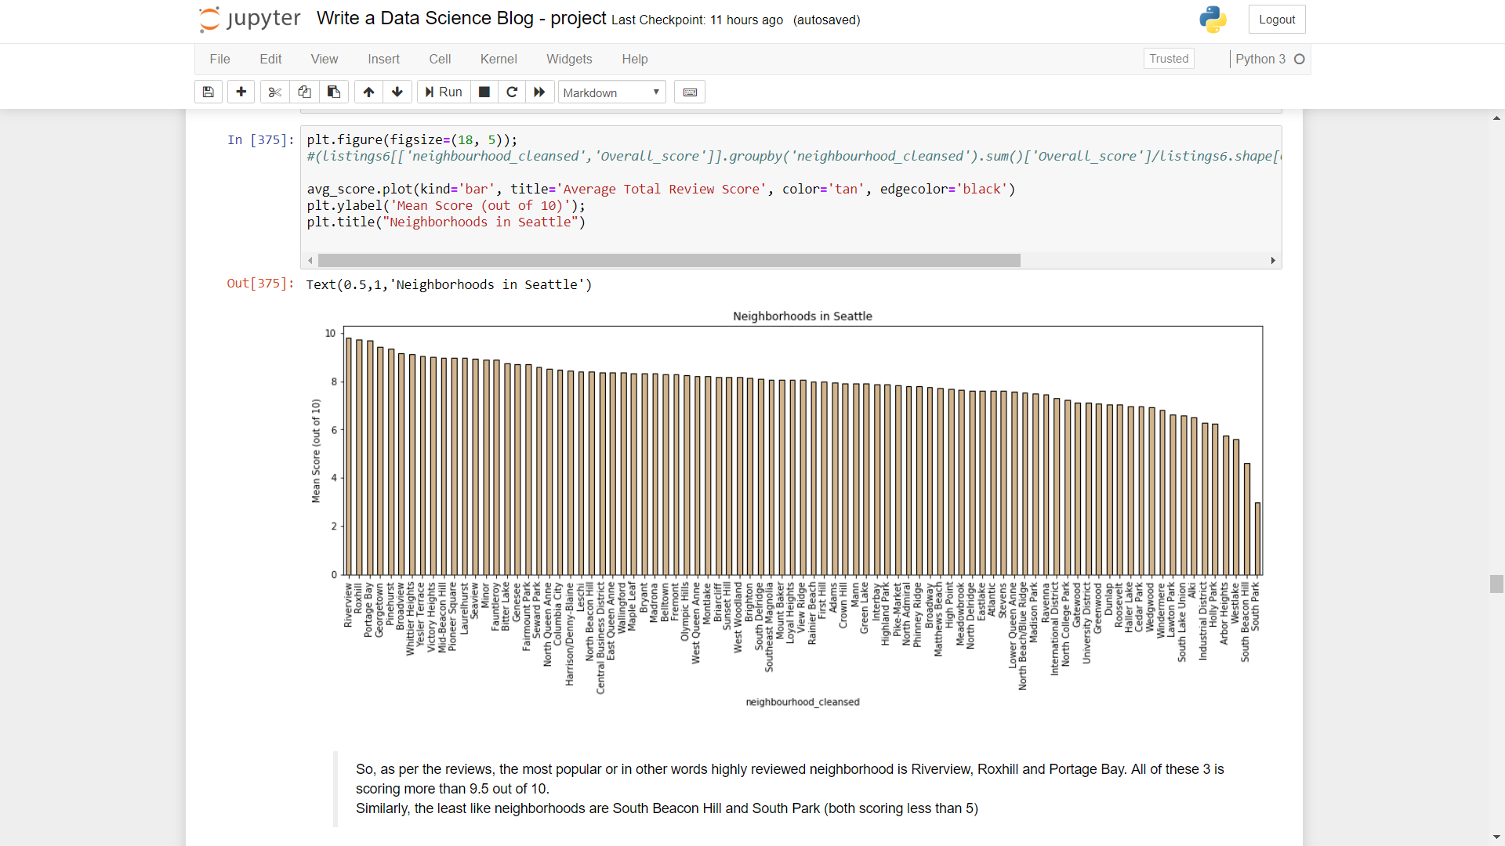

As seen from the above graph, as per the reviews, the most popular or in other words highly reviewed neighborhood is Riverview, Roxhill and Portage Bay. All of these 3 is scoring more than 9.5 out of 10. Similarly, the least like neighborhoods are South Beacon Hill and South Park (both scoring less than 5). It would be interesting to see the performance of neighborhoods on the basis of combination of total number of listings and average score, because on the closer checks I saw that neighborhoods generating higher scores had not much listings.

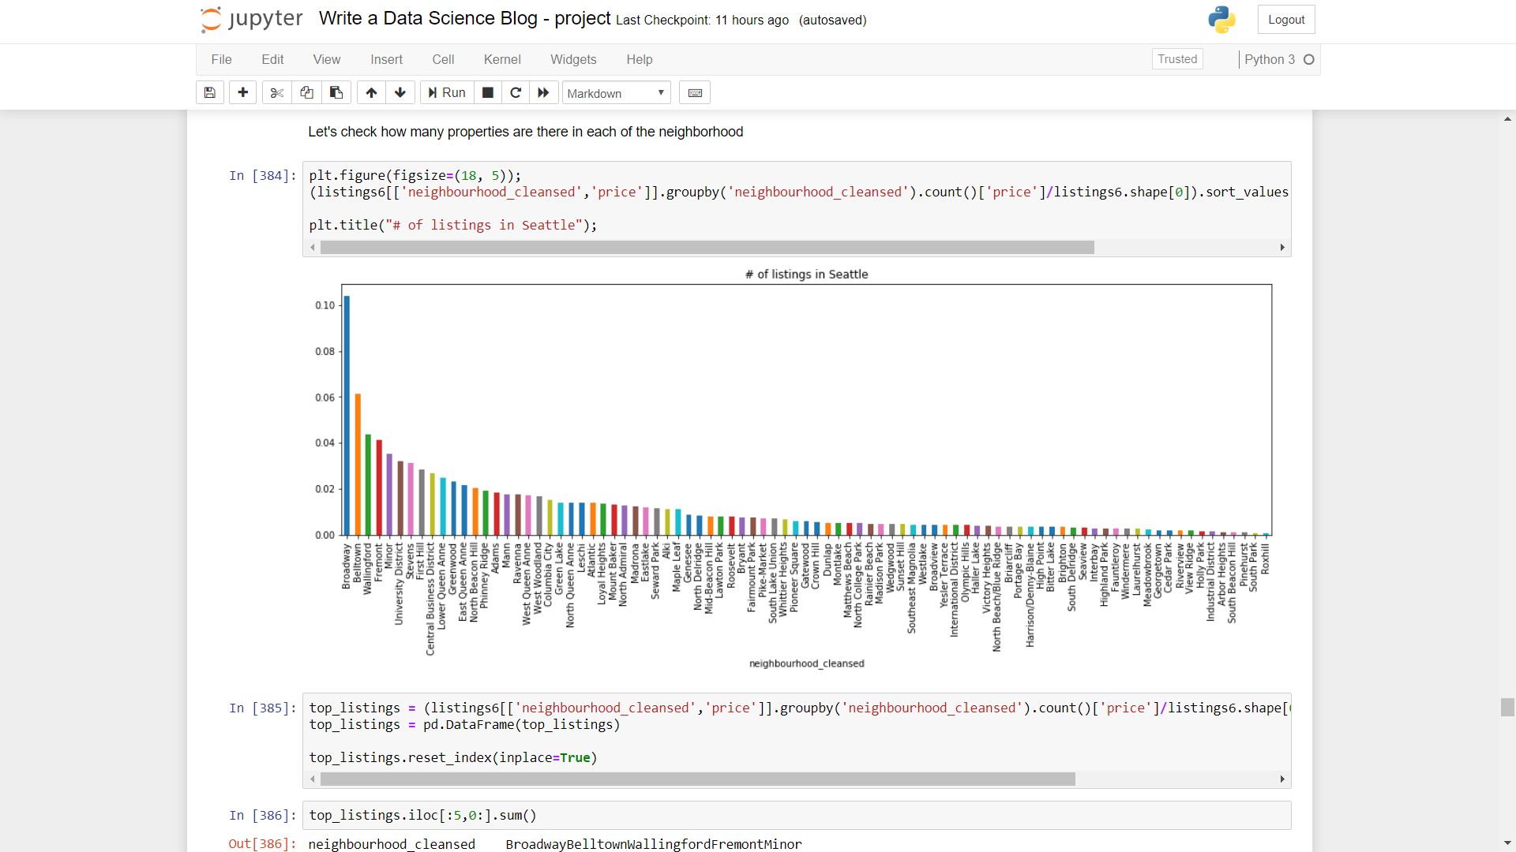

The top 5 neighborhoods contribute to around 28% of overall Seattle while top 10 contributes to around 43%. Most popular neighborhoods like Riverview, Roxhill and portage Bay doesn't have very high listings. Same is the case with bottom most neighborhoods wrt average scores of ratings

**Part 2: Fluctuation of price across month**

A simple chart plotted by month and average cost per listings reveals that there isn’t much fluctuation. However, price is gently rising from the summer of 2016 and keep on doing so till future months. Average cost in January of 2017 vs 2016 is higher.

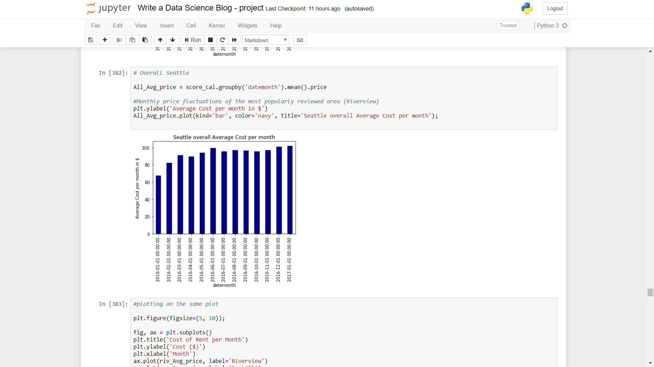

This is interesting as one could infer that in general there’s steady increase of price in the properties listed in Seattle.

I also checked the price listed for properties for the most and least popular neighborhoods (identified in part1)

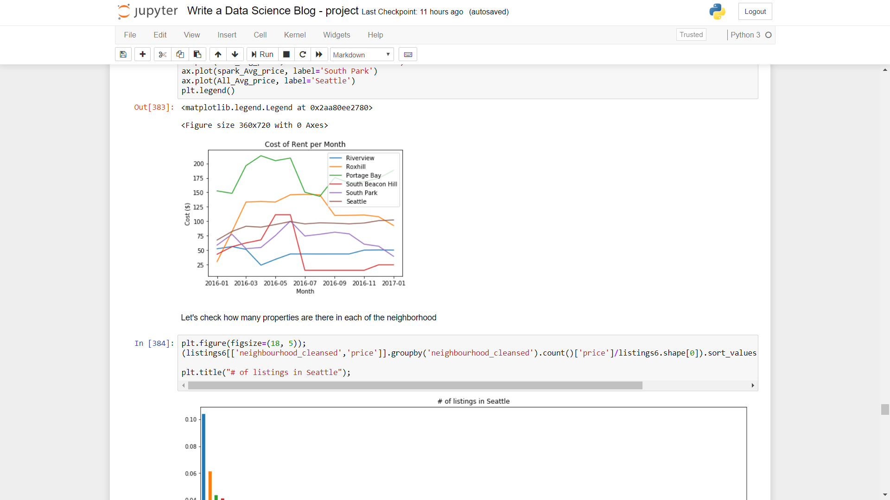

Key takeaways from the above image was

* The overall rent trend of Seattle was almost a straight line without dips and spike. However, for other 5 neighborhoods we saw some actual trends and interesting observation
* For bottom most neighborhood, South Beacon Hill and South Park were having prices below the overall Seattle average. While for top most neighborhood prices were trending above the overall Seattle average price
* The exception was the top most popular neighborhood - Riverview. It had among the lowest average prices per rent per month (could this be the important reason for people to rate it highly?)
* Better rated neighborhood have average prices higher than that of Seattle, probably better amenities are being provided
* These neighborhood showed some kind of spike in the summer month

**Part 3: Important amenities**

There are multiple criteria to list for / search a property: from a shared room to an entire house, with different amenities from washing machine to swimming pool. The list of the possible amenities that a property can have contains a catalog of 100+ different items.

In this analysis I mainly tried find the main profiles that we can find in Seattle. As we can see below TV, Family/Kid friendly, Fire extinguisher were the top 3 amenities.

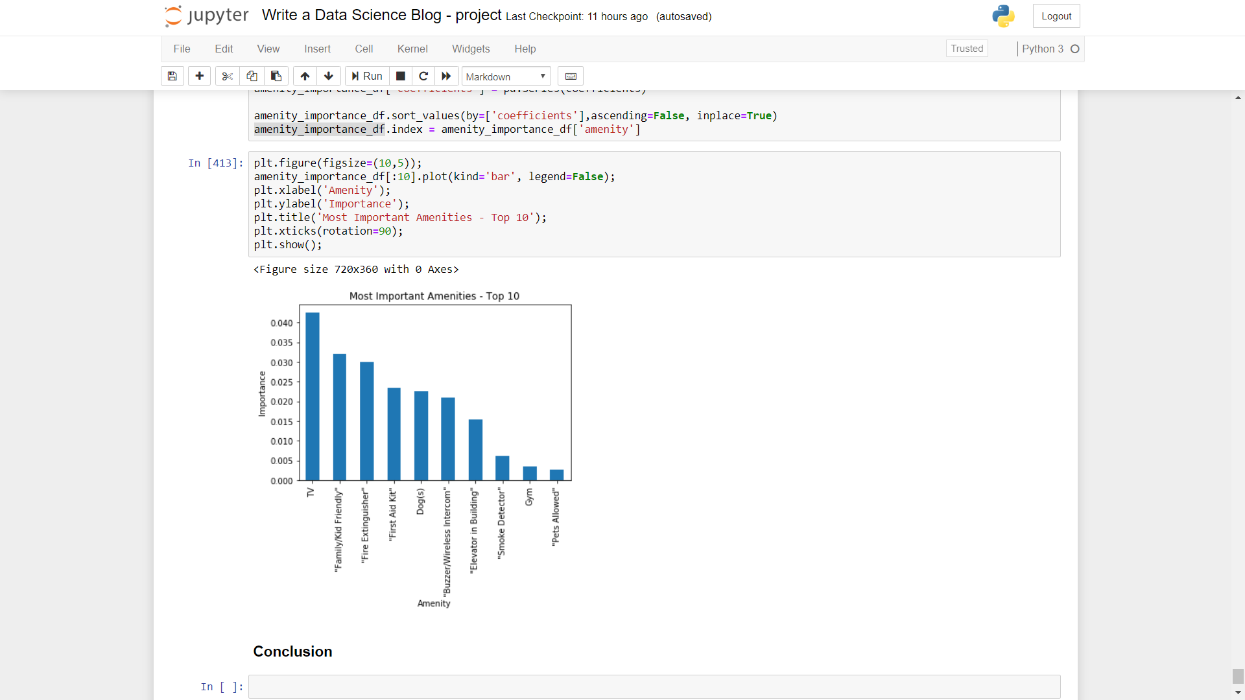

**Part 4: Features deciding price of the properties for rent**

I wondered after looking at the dataset – weather there could be any important features deciding the price of the properties listed to be rented. The analysis I performed generated the image below. As one would expect number of accommodates deciding the price occupies the #1 spot. Number of bedrooms, bathrooms and TV comes in next.

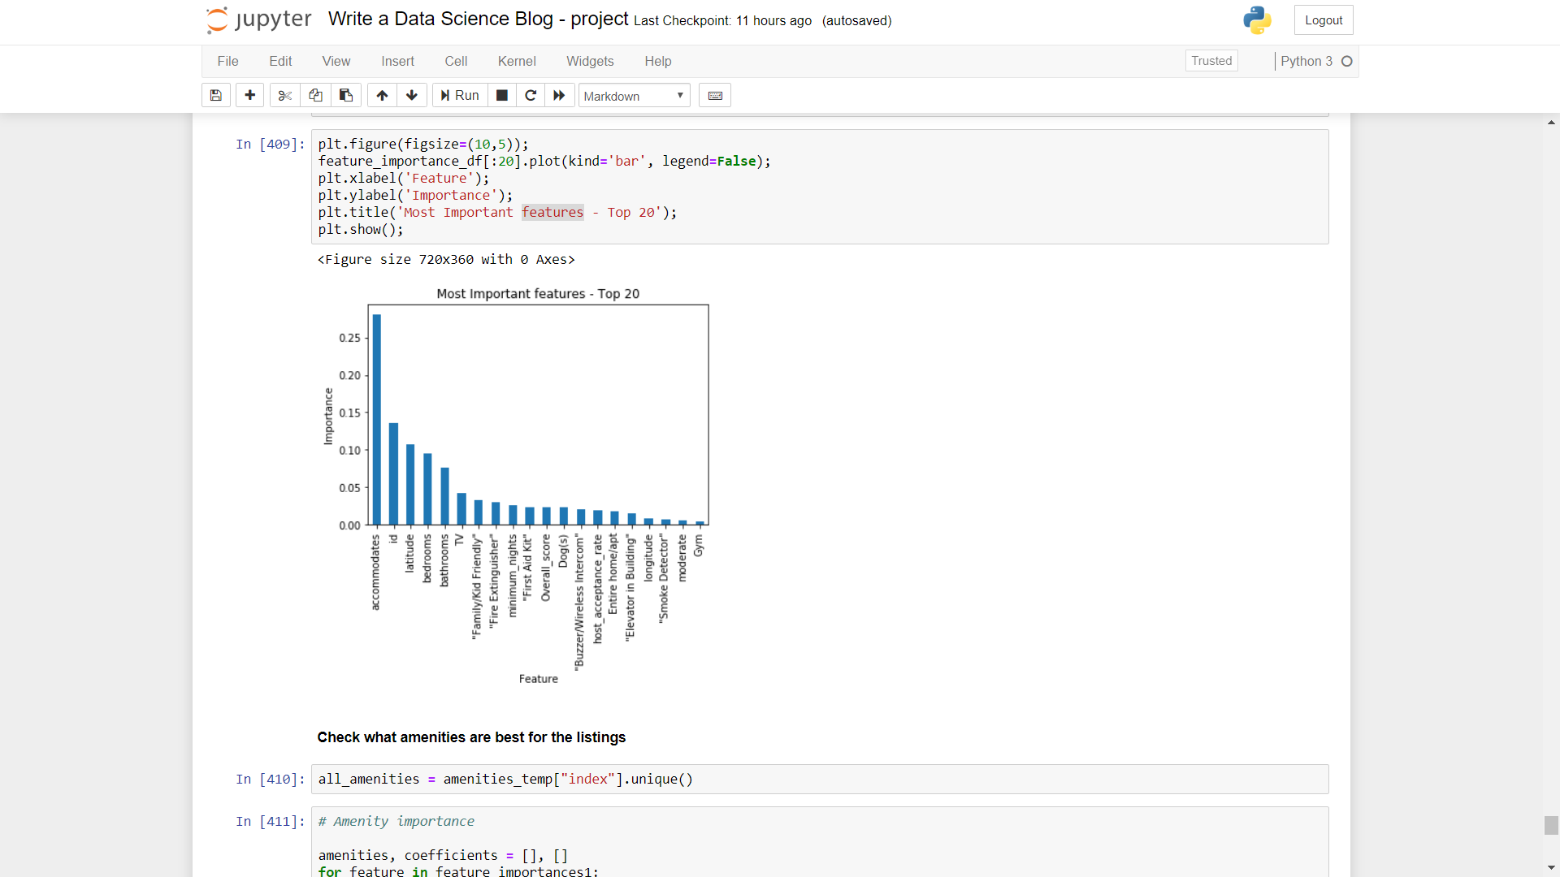

**Conclusion**

Through this article we went through Seattle Airbnb dataset and some visualizations to understand what are the major popular areas in Seattle are. We also understood the following:

1. Most popular may not be holding many properties for rent
2. Average prices per properties are trending upward
3. Better rated neighborhood have average prices higher than that of Seattle, probably better amenities are being provided
4. Amenities such as TV, family friendliness, fire extinguisher are driving reasons for higher prices

This article was written for educational purpose and not a complete formal study. I hope this article helps you decide on which neighborhood to choose from when you are in Seattle next.

If you have any feedback please provide that in the comment below.

If you want you can go through my codes and findings in detail in the GitHub profile here.